**FACULTY OF COMPUTER APPLICATIONS**

**UNDERTAKING BY STUDENT GOING FOR AN INDUSTRIAL VISIT**

I _Kundan Kumar Rai, having Roll No __22/FCA/MCA/035___ _, studying in _______2ND_____ semester of _______MCA_______________ programme. The department has arranged an Industrial visit to PUSA research Institute, Delhi on 18th April, 2023 (Tuesday) for my class. I am willing to go for this industrial visit to have better understanding of technology and research.

The Department / University will not be held liable for any mishap / eventuality during the trip.

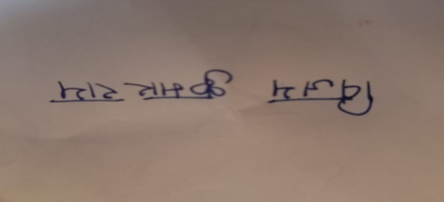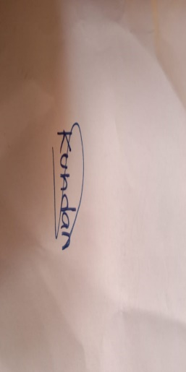

**Signature of Signature of**

**Student Student’s Parents / Guardian**

**Mob. No.: 9304692560 Parents / Guardin Mob. No.:7479690332**

**Date: 15/04/2023**